NAME: RAJA RAYYAN AMEER
REG. NO.: 23-CP-25
SECTION: ALPHA
SUBJECT: DATABASE MANAGEMENT SYSTEM
DEPARTMENT: COMPUTER ENGINEERING
TEACHER: SIR SHAHID
LAB 4
Task 1:
In this task, you will define the `customer` table with fields: customer_id (pk), name, email (unique), and phone. Define the `Customer` table with fields: customer_id (PK), name, email (UNIQUE), and phone. Use appropriate data types.
Query:
CREATE DATABASE Lab4;
USE Lab4;

CREATE TABLE CUSTOMER(
customer_id int primary key,
name varchar(50),
email varchar(50) unique,
phone int
);
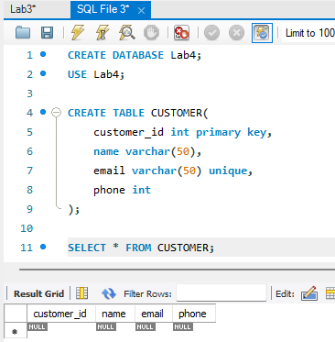
Task 2:
In this task, you will define the `product` table with fields: product_id (pk), product_name, price, and stock. Define the `Product` table with fields: product_id (PK), product_name, price, and stock. Add a constraint that price must be greater than 0.
Query:
CREATE TABLE PRODUCT(
product_id int primary key,
product_name varchar(50),
price float check (price>0),
stock varchar(50)
);

SELECT * FROM PRODUCT;
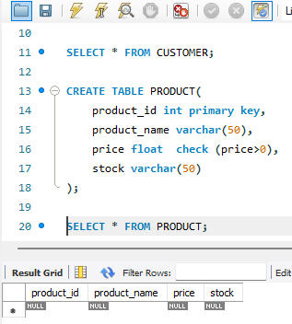
Task 3:
In this task, you will create the `order` table with fields: order_id (pk), order_date, customer_id (fk). Create the `Order` table with fields: order_id (PK), order_date, customer_id (FK). Ensure customer_id references the Customer table.
Query:
CREATE TABLE ORDER1(
order_id int primary key,
order_date date,
customer_id int,
foreign key(customer_id) references CUSTOMER(customer_id)
);

select * from ORDER1;

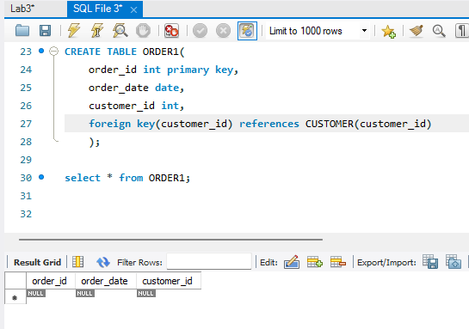
Task 4:
In this task, you will add a new field `status` to the `order` table with default value 'pending'. Add a new field `status` to the `Order` table with default value 'Pending'.
Query:
alter table ORDER1 add status varchar(20) default'Pending';
select * from ORDER1;
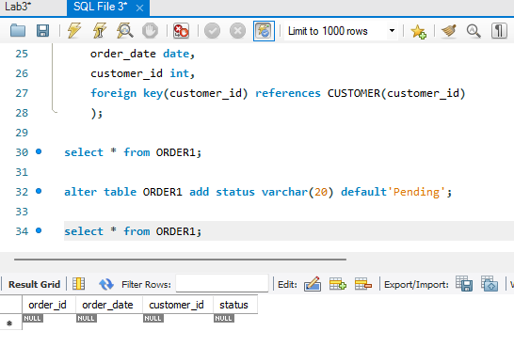
Task 5:
In this task, you will create the `orderitem` table with fields: order_id (fk), product_id (fk), quantity. Create the `OrderItem` table with fields: order_id (FK), product_id (FK), quantity. Use a composite primary key (order_id, product_id).
Query:
CREATE TABLE ORDERItem(
order_id int,
quantity int,
primary key(order_id,product_id),
foreign key (order_id) references ORDER1(order_id),
product_id int,
foreign key (product_id) references PRODUCT(product_id)
);

select * from ORDERItem;
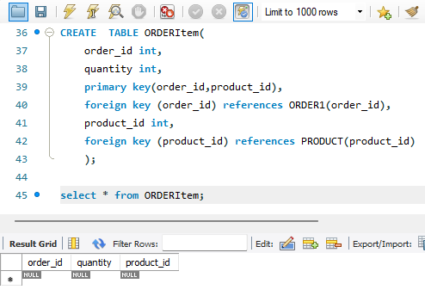
Task 6:
In this task, you will create the `employee` table with fields: emp_id (pk), name, role, hire_date. Create the `Employee` table with fields: emp_id (PK), name, role, hire_date. Add a constraint that hire_date cannot be in the future.
Query:
CREATE TABLE employee(
emp_id int primary key,
e_name varchar(50),
e_role varchar(50),
hire_date date
);

select * from employee;
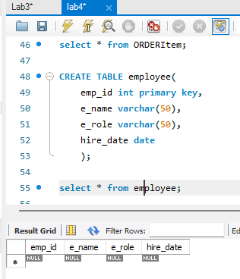
Task 7:
In this task, you will use `show tables` or `\d` (in postgresql) to view all created tables and confirm structure. Use `SHOW TABLES` or `\d` (in PostgreSQL) to view all created tables and confirm structure.
Query:
show tables;
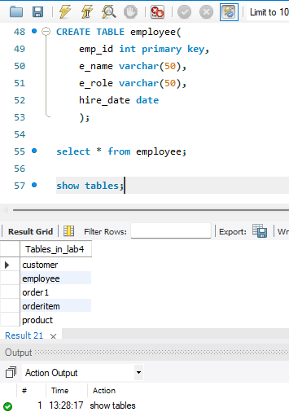
Task 8:
In this task, you will drop the `orderitem` table and recreate it using the same schema. Drop the `OrderItem` table and recreate it using the same schema.
Query:
drop table if exists ORDERItem;

show tables;
create table ORDERItem(
order_id int primary key);

show tables;
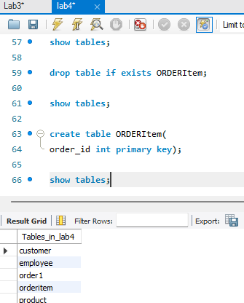
Task 9:
In this task, you will learn how to modify an existing table by adding a new column. This is useful for extending your database design as requirements evolve. To add a new column for email addresses:
Query:
alter table PRODUCT add category varchar(20) default'null';

select * from product ;
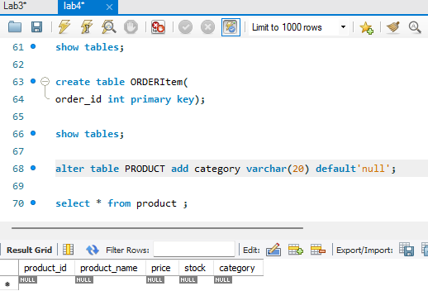
Task 10:
In this task, you will write a full sql script combining all table definitions and constraints, and run it in your dbms. Write a full SQL script combining all table definitions and constraints, and run it in your DBMS.
Query:
CREATE DATABASE Lab4;
USE Lab4;

CREATE TABLE CUSTOMER(
customer_id int primary key,
name varchar(50),
email varchar(50) unique,
phone int
);
CREATE TABLE SUPPLIER(
supplier_id int primary key,
supplier_name varchar(50)
);
SELECT * FROM CUSTOMER;

CREATE TABLE PRODUCT(
product_id int primary key,
product_name varchar(50),
price float check (price>0),
stock varchar(50),
supplier_id int,
foreign key (supplier_id) references SUPPLIER(supplier_id)
);

SELECT * FROM PRODUCT;

CREATE TABLE ORDER1(
order_id int primary key,
order_date date,
customer_id int,
status varchar(20) default 'Pending',
foreign key(customer_id) references CUSTOMER(customer_id)
);

select * from ORDER1;

alter table ORDER1 add status varchar(20) default'Pending';

select * from ORDER1;

CREATE TABLE ORDERItem(
order_id int,
quantity int,
primary key(order_id,product_id),
foreign key (order_id) references ORDER1(order_id),
product_id int,
foreign key (product_id) references PRODUCT(product_id)
);

select * from ORDERItem;

CREATE TABLE employee(
emp_id int primary key,
e_name varchar(50) not null,
e_role varchar(50) check ('Manager,Cashier,Stocker'),
hire_date date
);

select * from employee;

show tables;

drop table if exists ORDERItem;

show tables;

create table ORDERItem(
order_id int primary key);

show tables;

alter table PRODUCT add category varchar(20) default'null';

select * from product ;

drop table if exists CUSTOMER;
CREATE TABLE CUSTOMER(
customer_id int primary key,
name varchar(50),
email varchar(50) unique,
phone int,
address varchar(50)
);

alter table ORDER1 rename column status to Order_status;

alter table ORDERItem modify quantity int check (quantity>0);
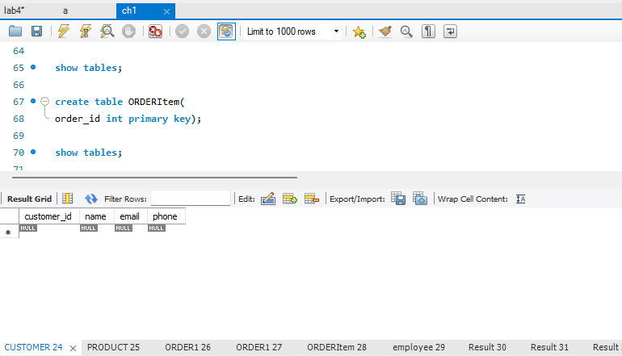
Challenge 1:
Design a `Supplier` table and link it to `Product` using a foreign key.
Query:
CREATE TABLE SUPPLIER(
supplier_id int primary key,
supplier_name varchar(50)
);
SELECT * FROM CUSTOMER;

CREATE TABLE PRODUCT(
product_id int primary key,
product_name varchar(50),
price float check (price>0),
stock varchar(50),
supplier_id int,
foreign key (supplier_id) references SUPPLIER(supplier_id)
);
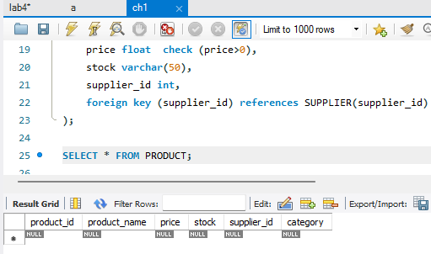
Challenge 2:
Ensure that each employee's name is not NULL and their role is either 'Manager', 'Cashier', or 'Stocker'.
Query:
CREATE TABLE employee(
emp_id int primary key,
e_name varchar(50) not null,
e_role varchar(50) check (e_role in('Manager','Cashier' , 'Stocker')),
hire_date date
);

select * from employee;
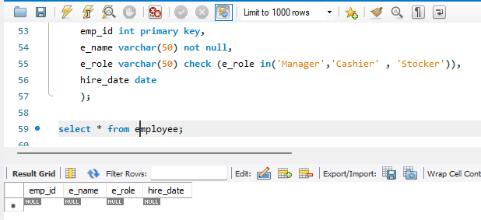
Challenge 3:
Create a constraint that each order must contain at least one item.
Query:
alter table ORDERItem modify quantity int check (quantity>0);
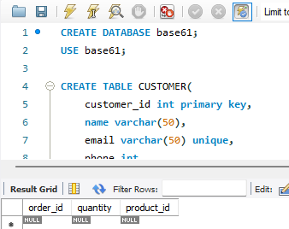
Challenge 4:
Write an SQL query to drop and re-create the `Customer` table with an added column for address.
Query:
drop table if exists ORDER1;

drop table if exists CUSTOMER;

CREATE TABLE CUSTOMER(
customer_id int primary key,
name varchar(50),
email varchar(50) unique,
phone int,
address varchar(50)
);
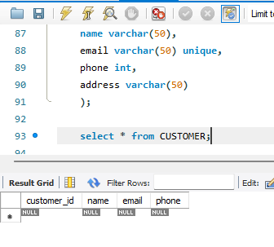
Challenge 5:
Use SQL to rename the `status` column in the `Order` table to `order_status`.
Query:
alter table ORDER1 rename column status to Order_status;
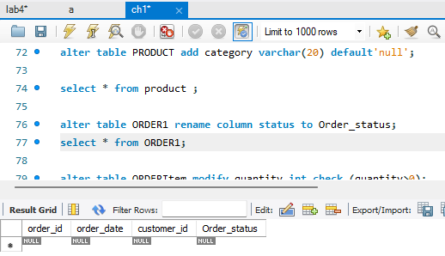
THE END

